**A close up of a sign

Description generated with very high confidence**

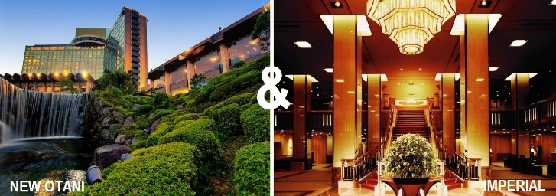

**HOTEL DISCOUNTS**

IMPERIAL HOTEL TOKYO

THE NEW OTANI HOTEL TOKYO

visit JAS-HOU.ORG for details

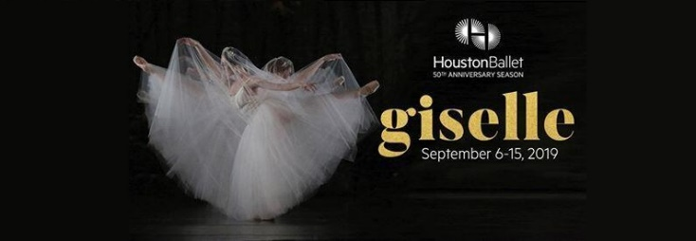

**HOUSTON BALLET DISCOUNT**

GISELLE

25% Discount on September 8th 2PM Performance (code 4309)

25% Discount on September 13th 7:30PM Performance (code 4309)

50% Discount on September 14th 1:30PM Performance (code 4310)

**KOKORO CARE PACKAGES**

MONTHLY SUBSCRIPTION BOXES

10% Discount off first order (code JASHOUS_10)

visit KOKORCARES.COM for details

**HOUSTON BALLET DISCOUNT**

LOCCALLY GROWN, WORLD RENOWNED

50% Discount on September 19th 7:30PM Performance (code 4311)

25% Discount on September 21st-29th Performances (code 4312)

**BEARD PAPA KATY**

10% OFF for JASH MEMBERS THROUGH SEPTEMBER

CELEBRATING 1 YEAR IN HOUSTON